Exercise
Q1. Write a program to replace a substring inside a string with other string ?
public class Assign1 {
public static void main(String[] args) {
String str=new String("HELLO JAVA");
str=str.replace("L","Z");
//replacing all occurance of a substring
System.out.println("modified string: "+str);
String str1="WELCOME TO THE TTN";
//replacing occurance between specific index
str=str.substring(0,8)+"NEWERS IN"+str.substring(10,str.length());
System.out.println("New string is:"+str);
}
}

Output:

Q2. Write a program to find the number of occurrences of the duplicate words in a string and print them ?
public class Assign1 {
public static void main(String[] args) {
String str="hi hello hi bye see hi good hello hi";
int count;
String s[]=str.split(" ");
int len= s.length;
String frequencyArray[]=new String[2*len];
int frequencyArrayIndex=0;
for(int i=0;i<len;i++)
{
count=1;
frequencyArray[frequencyArrayIndex]=s[i];
for(int j=i+1;j<len;j++)
{
if(s[i].equals(s[j]))
{
count++;
for(int k=j;k<len-1;k++)
s[k]=s[k+1];
len--;
j--;
}
}
frequencyArray[++frequencyArrayIndex]=String.valueOf(count);
frequencyArrayIndex++;
}
System.out.println("Printing the Occurances of duplicate words: ");
System.out.println("Words \t frequency");
for(int i=0;i<frequencyArrayIndex;i+=2) {
if(Integer.parseInt(frequencyArray[i+1])>1)
System.out.println(frequencyArray[i] + "\t\t\t" + frequencyArray[i+1]);
}
}
}

Output:
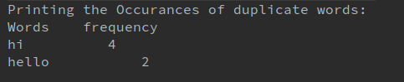

Q3. Write a program to find the number of occurrences of a character in a string without using loop?
public class Assign1 {
public static void main(String[] args) {
String str="welcome to the ttn";
int len=str.length();
str=str.replace("t","");
int len2=str.length();
System.out.println("no. of occurance of t= "+(len-len2));
}
}
Output:

Q4. Calculate the number & Percentage Of Lowercase Letters,Uppercase Letters, Digits And Other Special Characters In A String
public class Assign1 {
public static void main(String[] args) {
String str="Welcome To the TTN, newers id no. 33##";
char ch[]=str.toCharArray();
int lowerCaseCount=0,upperCaseCount=0,digitCount=0,specialcharCount=0;
for(int i=0;i<ch.length;i++)
{
if(Character.isUpperCase(ch[i]))
upperCaseCount++;
else if(Character.isLowerCase(ch[i]))
lowerCaseCount++;
else if(Character.isDigit(ch[i]))
digitCount++;
else
specialcharCount++;
}
System.out.println("upper case count = "+upperCaseCount);
System.out.println("lower case count = "+lowerCaseCount);
System.out.println("digit count = "+digitCount);
System.out.println("special char count = "+specialcharCount);
}
}
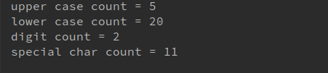
OUTPUT:

Q5. Find common elements between two arrays.
import java.util.Arrays;
public class Assign1 {
public static void main(String[] args) {
int array1[]=new int[]{2,1,4,5,3};
int array2[]=new int[]{6,4,5,7,3};
Arrays.sort(array1);
Arrays.sort(array2);
for(int i=0,j=0;i<array1.length && j<array2.length;) {
if(array1[i]==array2[j])
{
System.out.println(array1[i]);
i++;
j++;
}
else if(array1[i]<array2[j]) {
i++;
}
else
j++;
}
}
}
output:


Q6. There is an array with every element repeated twice except one. Find that element
public class Assign1 {
public static void main(String[] args) {
int array1[]=new int[]{1,2,3,4,5,4,3,2,1};
int result=array1[0];
for(int i=1;i<array1.length;i++)
result=result^array1[i];
System.out.println("Non-repeating element= "+result);
}
}

Output:

Q7. Write a program to print your Firstname,LastName & age using static block,static method & static variable respectively
public class Assign1 {
static String firstName="Amarjeet";
static String lastName="Malik";
static int age=21;
static {
System.out.println("inside static block");
System.out.println("first name="+firstName);
System.out.println("last name="+lastName);
System.out.println("age= "+age);
}
static void print(){
System.out.println("Inside print method");
System.out.println("first name="+firstName);
System.out.println("last name="+lastName);
System.out.println("age= "+age);
}
public static void main(String[] args) throws Exception {
int array1[]=new int[]{1,2,3,4,5,4,3,2,1};
print();
System.out.println("Inside main (using class name)(optional)");
System.out.println("first name="+Assign1.firstName);
System.out.println("last name="+Assign1.lastName);
System.out.println("age= "+Assign1.age);
}
}
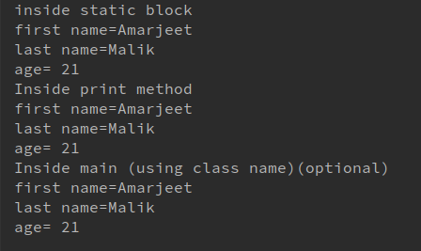
Output:

Q8. Write a program to reverse a string and remove character from index 4 to index 9 from the reversed string using String Buffer
public class Assign1 {
public static void main(String[] args) {
StringBuffer stringBuffer=new StringBuffer("Welcome newers in Techfluence");
stringBuffer.reverse();
System.out.println(stringBuffer.replace(4,9,""));
}
}
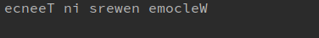
output:

Q9.Write a program to display values of enums using a constructor & getPrice() method (Example display house & their prices)
public class Assign1 {
public static void main(String[] args) {
System.out.println("all house prices:");
House h1[]=House.values();
//using for each loop
// for(House h:House.values())
// {
// System.out.println(h+" costs "+h.getPrice()+" rs.");
// }
//using for loop
for(int i=0;i<House.values().length;i++) //House.values() gives me array of values
{
System.out.println(h1[i]+" costs "+h1[i].getPrice()+" rs.");
}
}
}
enum House{
house1(1000),house2(2000),house3(3000);
int price;
House(int price) {
this.price = price;
}
public int getPrice() {
return price;
}
}
output:
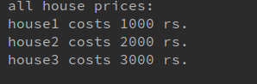

Q10.Write a single program for following operation using overloading
A) Adding 2 integer number
B) Adding 2 double
C) multiplying 2 float
D) multiplying 2 int
E) concate 2 string
F) Concate 3 String
public class Assign1 {
int add(int num1,int num2){
return num1+num2;
}
double add(double num1,double num2)
{
return num1+num2;
}
int multiply(int num1,int num2)
{
return num1*num2;
}
float multiply(float num1,float num2)
{
return num1*num2;
}
String concate(String str1,String str2)
{
return str1.concat(str2);
}
String concate(String str1,String str2,String str3)
{
return str1.concat(str2).concat(str3);
}
//concatenation of any number of String argument using variable length argument
/*
String concatenate(String ...string)
{
String res="";
for(int i=0;i<string.length;i++)
{
res=res.concat(string[i]);
}
return res;
}
*/
public static void main(String[] args) {
Assign1 assign=new Assign1();
int sumOfInteger=assign.add(10,20);
double sumOfDouble=assign.add(13.36,14.64);
int multiplyOfInteger=assign.multiply(12,6);
float multiplyOfFloat=assign.multiply(12.4f,5);
String concateOfTwoString=assign.concate("a","b");
String concateOfThreeString=assign.concate("a","b","c");
System.out.println("sum of two integer"+sumOfInteger);
System.out.println("sum of two double numbers"+sumOfDouble);
System.out.println("multiply of two integer numbers"+multiplyOfInteger);
System.out.println("multiply of two float numbers"+multiplyOfFloat);
System.out.println("concatenation of two string= "+concateOfTwoString);
System.out.println("concatenation of three string= "+concateOfThreeString);
}
}
Output:
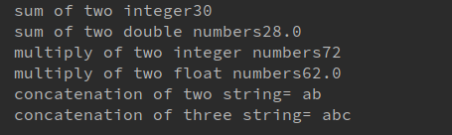

Q11.Create 3 sub class of bank SBI,BOI,ICICI all 4 should have method called getDetails which provide there specific details like rateofinterest etc,print details of every banks
abstract class Bank {
float rateOfInterest;
float cashReserveRatio;
float statutoryLiquidityRatio;
abstract void getDetails();
}
class SBI extends Bank{
SBI(float r,float c,float s){
this.rateOfInterest=r;
this.cashReserveRatio=c;
this.statutoryLiquidityRatio=s;
}
@Override
void getDetails() {
System.out.println("SBI Details:");
System.out.println("rate of interest= "+this.rateOfInterest);
System.out.println("cash reserve ratio= "+this.cashReserveRatio);
System.out.println("statutoryLiquidityRatio= "+this.statutoryLiquidityRatio);
}
}
class BOI extends Bank{
BOI(float r,float c,float s){
this.rateOfInterest=r;
this.cashReserveRatio=c;
this.statutoryLiquidityRatio=s;
}
@Override
void getDetails() {
System.out.println("BOI Details:");
System.out.println("rate of interest= "+this.rateOfInterest);
System.out.println("cash reserve ratio= "+this.cashReserveRatio);
System.out.println("statutoryLiquidityRatio= "+this.statutoryLiquidityRatio);
}
}
class ICICI extends Bank{
ICICI(float r,float c,float s){
this.rateOfInterest=r;
this.cashReserveRatio=c;
this.statutoryLiquidityRatio=s;
}
@Override
void getDetails() {
System.out.println("ICICI Details:");
System.out.println("rate of interest= "+this.rateOfInterest);
System.out.println("cash reserve ratio= "+this.cashReserveRatio);
System.out.println("statutoryLiquidityRatio= "+this.statutoryLiquidityRatio);
}
}
class Print{
public static void main(String[] args) {
Bank bank=new SBI(7.5f,4.00f,21.00f);
bank.getDetails();
Bank bank1=new BOI(7f,3.86f,22.00f);
bank1.getDetails();
Bank bank2=new ICICI(8.0f,4.2f,20.50f);
bank2.getDetails();
}
}
Output:
